Beechmont Presbyterian Church March 13, 2016
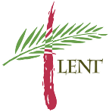
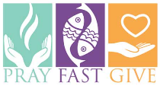
5th Sunday in Lent
Welcome Rev. Emily Enders Odom, Guest Preacher!
11:00 a.m. Bi-Lingual Worship
Children & Youth will be invited to attend Sunday School and escorted to their class after the scripture reading.
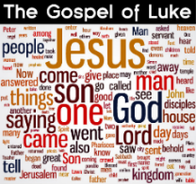
Bible Study Wednesdays
Weekly 7:00 p.m.
Join us for fellowship and learning every Wednesday night in the Library! We are studying the Gospel of Luke.
FINAL MEETING - ELL (English Language Learner)
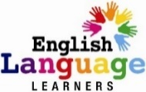
English Conversation Group - Thursday 6:30 – 7:30 p.m. in the Small Fellowship Hall
In partnership with Crescent Hill Presbyterian Church, Soni Castleberry will lead this group’s final session on March 17th! No Childcare is available. Enter the building through the door by the Library.

Thursday, March 17, 2016
BPC Stated Session Meeting 6:30 p.m. – Library
This meeting is open to everyone!
Moderator: Rev. Marissa Galván-Valle
Parish Associates: Rev. Debbie Braaksma & Rev. KT Ockels
Members of Session:
Class of 2016 Class of 2017 Class of 2018
Kevin Jett Anni Kac Del Braaksma
Sandy Lamp Hugh Proctor Lionel Derenoncourt
Ellen Sherby Blanca Valle Rhonda Magrey

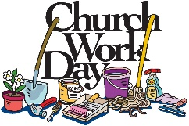
BPC Work Day March 19th 9 a.m. - noon
Calling all helpers!! Just like our homes, the church needs some deep SPRING Cleaning & Organization. We will be taking advantage of the Beechmont Neighborhood’s “Junk Set Out Period” and large items no longer needed will be put to the curb. Volunteers are needed! “Many hands make light work!”

Cedar Ridge Camp: "Basketball, Beer and BBQ" Fund Raiser - March 19th in the evening. Cedar Ridge Camp will host a fund raiser for summer camp Tickets are $20 in advance via their website or $25 at the door.

Sunday, March 20th2016 – Holy Week Begins!
Passion / Palm Sunday
10:00–11:00 Palm Sunday Breakfast Fellowship
Enjoy breakfast items, juice & coffee, followed by a “Palm Waving & Singing Processional” from the Large Fellowship Hall to the sanctuary!
11:00 Processional from Lg Fellowship Hall to
Bi-Lingual Worship Service
Children & Youth will be invited to attend Sunday School and escorted to their class after the scripture reading.

Thursday, March 24th2016
Maundy Thursday “Simple Soup Supper”- 6:00 p.m.
Bring a soup or sandwich, to share. Bread/Crackers will be provided. A special service will be held during this time.

Sunday, March 27th2016
Resurrection of the Lord / Easter
10:00 - Continental Breakfast Fellowship
Come enjoy pastries, fruits & other refreshments and intergenerational activities before the Easter Egg Hunt begins!
10:30 - Easter Egg Hunt
For the “young crowd:” Elementary school-age children and younger.
11:00 a.m. - Joint Multi-Lingual Worship Service
(No Sunday School)
Flowering of the Cross during the worship service
Bring a flower from your garden!
One Great Hours of Sharing Special Offering
A gift to One Great Hour of Sharing enables the church to share God’s love with our neighbors-in-need around the world by providing relief to those affected by natural disasters, provide food to the hungry, and helping to empower the poor and oppressed. Your gifts to One Great Hour of Sharing make a real difference in the lives of their recipients. Please give generously.
-Presbyterian Disaster Assistance -Presbyterian Hunger Program
-Self-Development of People

Families Helping Families – Tuesday, March 22 – 6 p.m.
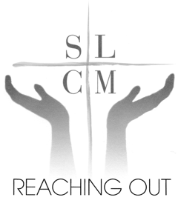
Hotel Louisville – 120 W. Broadway 40202
You are invited to join SLCM as they celebrate an evening of remembering the past in laughter, reliving memorable times of our lives and those of SLCM with special friends with a dinner, program, and special entertainment. Special recognition will be given to longtime supporter Metro Councilwoman Marianne Butler. Entertainment provided by Ladies for Liberty. Tickets are $50 or special sponsorship rates. For more information, contact Joyce Whalin at 361-7763 or funddevelopment@slcm.org.

2016 SYNOD OF LIVING WATERS PW TRIENNIAL
June 8-11, 2016. First Presbyterian Church, Franklin, TN. The Synod’s Presbyterian Women Triennial will be held on June 8-11, 2016. Place: First Presbyterian Church, Franklin, TN.
Theme: “Follow Me.” Keynote speakers: Carol Winkler—Churchwide PW Moderator, Judy Persons— Churchwide PW Vice Moderator, and the Rev. Sara (Sally) Hughes. There will be an introduction to the 2016-2017 Bible Study, “Who Is Jesus?”, led by Dee Koza, a variety of workshops, and a gift shop filled with handmade items crafted by PWs from our Synod. Registration for the whole Gathering prior to May 1st is $150; afterward it is $165. Daily registration prior to May 1st for Wed., Thurs. and Fri. is $50 each day, for Saturday, $25. After May 1st add a late fee of $5 per day. Rooms are being held at Americas Best Value Inn until March 31st and at the Comfort Inn until May 7th; participants are responsible for their own reservations. Registration material will be available at our Spring Gathering.

Nursery/Toddler Workers Needed
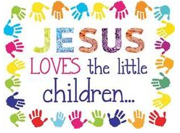
We are blessed to have young children as part of our church family and are in need of a child care worker to tend to the “youngest among us” up to age 5.
If you are able to volunteer your services regularly/occasionally, or know of someone who is responsible and looking to earn a small amount of money by providing child care services on Sunday and other times if possible, please contact Ellen Sherby or Debbie Braaksma.
”I am the church, you are the church, we are the church together….”

ATTENTION YOUTH & PARENTS Looking Ahead: July 2016

Presbyterian Youth Triennium – July 19-23, 2016
Location: Purdue University, Indianapolis, IN
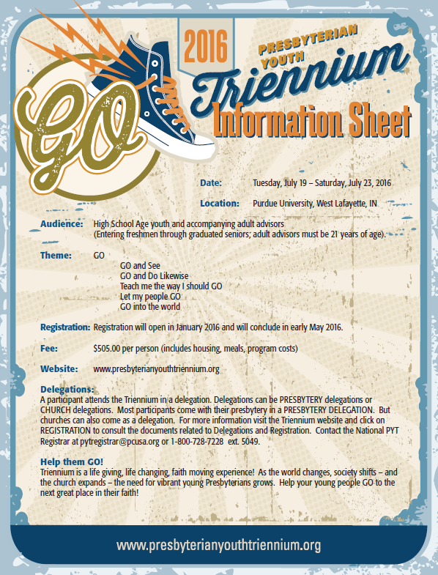
is a gathering for high school age youth from the Presbyterian Church (USA) and the Cumberland Presbyterian Church that occurs every three years. The 2016 event is July 19-23, 2016 at Purdue University. The theme for the 2016 event is “GO.” Scholarships are available. Let Ellen Sherby, Alonzo Johnson, or KT Ockels know of your interest.

Reproduced from Presbyterian News Service

‘Educate a Child’ Initiative Aims to Remove Stumbling Blocks
Johnson, Lindner and Bairby
introduce PC(USA) education plan at APCE workshop.
February 11, 2016
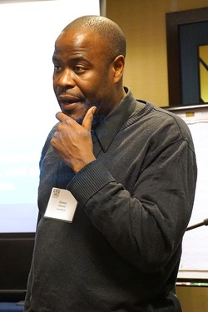
Presbyterian News Service
By Emily Enders Odom
CHICAGO
They don’t call Jesus “the Teacher” for nothing.
With those words—attributed to the great African-American teacher advocate, author, and scholar, Dr. Cain Hope Felder—the Rev. Alonzo Johnson opened his team’s “Educate a Child” presentation, one of some 60 workshops offered at the 2016 Association of Presbyterian Church Educators (APCE) gathering,
held from January 27–30
In downtown Chicago. Alonzo Johnson, PC(USA)
‘Educate a Child, Transform the World’
initiative coordinator, speaks at the
January 2016 meeting of APCE in Chicago.
—Emily Enders Odom
Johnson, convener of the “Educate a Child, Transform the World” national initiative of the Presbyterian Church (U.S.A.), was joined by his staff colleagues, the Rev. Dr. Eileen W. Lindner, pastor and author of numerous books and articles on child advocacy, and the Rev. Ginna Bairby, managing editor of the PC(USA)’s Unbound: An Interactive Journal of Christian Social Justice.
“Educate a Child,” approved by the 221st General Assembly of the PC(USA), calls on Presbyterians “to work with partners in the U.S. and worldwide to improve the quality of education for 1 million children by 2020.” The initiative has two priorities: to strengthen early childhood education and to decrease the school dropout rate.
Johnson began by inviting participants into a dialogue around major challenges children face today, notably poverty, the quality of their schools, and the often-absent commitment of their parents.
“We as God’s people—as Presbyterians—are called to do something about the problem of education today,” he said. “We seek to engage congregations to take a stand and do something for young people so that they can live lives of self-determination.”
Several attendees shared the ways in which their congregations are already working to address and strengthen early childhood education through programs such as STAIR (Start the Adventure in Reading), a volunteer-based, non-profit children’s literacy organization.
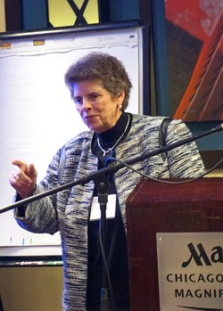
“The power of being part of an initiative is to be able to excite you, and to think of the kinds of things that can happen in our churches,” Johnson said, “especially because we hold education as a priority in our denomination. We have an opportunity to make a difference.”
Lindner, in her presentation, spoke to the advocacy component of the initiative, addressing the “why” of it in three major points.
“There are lots of reasons in our theology,” she said. “We’re the only denomination that calls our clergy ‘teaching elders.’ We’re the only one that puts them in academic robes. Another point of Reformed theology is the ‘imago dei,’ the profound belief that on the face of every child is the face of God. The preservation of that ‘imago dei’ is important.”
Eileen Lindner speaks on the PC(USA) ‘Educate a Child’ initiative at the January 2016 meeting of APCE in Chicago. —Emily Enders Odom
The Reformers were also informed by scripture, Lindner said, especially Mark 9:42, which she cited as “the only sanction on the lips of Jesus anywhere in scripture,” and which she paraphrased by saying, “I would rather see you dead…than to cause one of these little ones to stumble.”
Her third point was that Presbyterians practice infant baptism, a very conscious decision on the part of the Reformers. “When we baptize, we ask the congregation, ‘Do you promise to support this child,’ to which the congregation responds, ‘We do and we will.’ But they don’t! My challenge to you today is that we have to keep those promises or stop baptizing. It’s a radical thing to say, but I think that’s where we are.”
Lindner walked participants through a congregational assessment tool—an important part of the initiative’s new toolkit—that helps churches to analyze the issues within their community and inventory their own congregational capacities to assist children or youth to better fulfill their educational goals.
“Doing this kind of an assessment allows you to bring to your congregation a prophetic word—a word about what we might be called to do,” she said. “I urge you not to go to the committee or session with the plan fully developed. Say what you know. Discern together what your plan should be. It will then have better ownership.”
Lindner emphasized the importance of “not getting lost” in this matter of child advocacy. “I hope that you will take to your hearts this challenge and find a way and share it with others,” she said. “We are called by Christ to remove stumbling blocks. You’ve got to update your program if you’re going to meet the needs of children.”
Bairby concluded the Jan. 28 presentation by talking through the initiative’s website and toolkit, informing participants that a new, informal congregational network is in the process of forming, so that churches and people who are starting to do an assessment can learn from each other.
One highlight of the website is the sharing of stories from PC(USA) congregations who are already making a difference.
“There are many more congregations doing this than we know about,” Bairby said. “Tell us your story—where you have experienced God in the world of child education and advocacy.”

Reminders for Next Weekend:
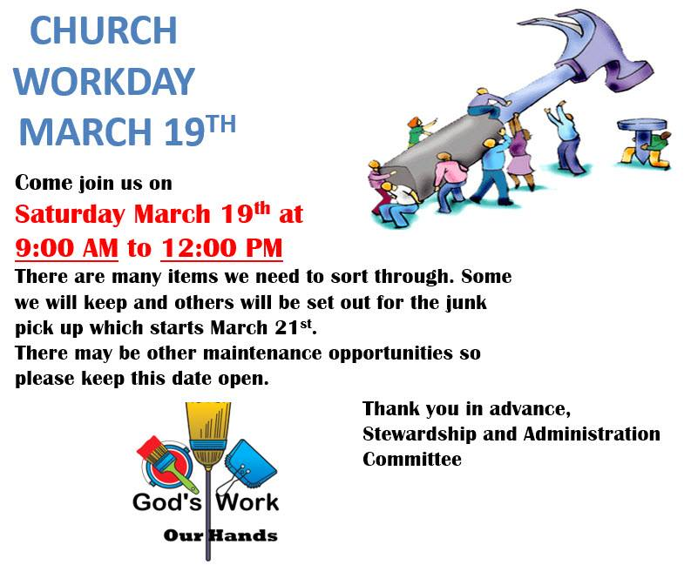
Palm Sunday:
Sunday, March 20th2016 – Holy Week Begins!
Passion / Palm Sunday
10:00–11:00 Palm Sunday Breakfast Fellowship
Enjoy breakfast items, juice & coffee, followed by a “Palm Waving & Singing Processional” from the Large Fellowship Hall to the sanctuary!

11:00 Processional from Lg Fellowship Hall to
Bi-Lingual Worship Service
Children & Youth will be invited to attend Sunday School and escorted to their class after the scripture reading.

